**Front End Engineering**

Project Report Semester-IV (Batch-2022)

**Health Hub**



**Supervised By: Submitted By:**

Himanshi(2210990403)

Heena(2210990398)

Himani(2210990401)

## Department of Computer Science and Engineering Chitkara University Institute of Engineering & Technology,

**Chitkara University, Punjab**

**ABSTRACT**

In the modern digital era, efficient access to healthcare services is paramount for enhancing patient satisfaction and overall health outcomes. This project presents the development of a comprehensive medical appointment scheduling website designed to streamline the process of booking medical appointments, accessing information about healthcare providers, and locating nearby hospitals.

The website features a user-friendly appointment scheduling form, enabling patients to easily select available time slots and specify their medical needs. Detailed doctor profiles provide critical information such as background, specialties, availability, and patient reviews, assisting users in making informed decisions about their healthcare. The nearby hospitals feature offers essential details about medical facilities in the patient's vicinity, including contact information, services provided, and directions, ensuring prompt access to healthcare in urgent situations.

The platform also includes a secure login/signup page, allowing patients to create accounts, manage their appointments, and personalize their experience. The Contact Us feature facilitates seamless communication between users and healthcare providers, enhancing engagement and support.

Future scope for the project includes the integration of telemedicine services, AI-driven appointment scheduling for improved efficiency, and the development of mobile applications to increase accessibility.

This project aims to improve the healthcare experience by providing a centralized, accessible, and efficient platform for managing medical appointments, thereby enhancing patient convenience, satisfaction, and overall healthcare outcomes.

**INDEX**

|  |  |  |  |
| --- | --- | --- | --- |
| **S.no** | | **Topics** | **Page No.** |
| **1.** | **Introduction** | | **4** |
| **2.** | **Problem Statement** | | **5** |
| **3.** | **Requirements** | | **6-7** |
| **4.** | **Objectives** | | **8** |
| **5.** | **Goals** | | **9** |
| **6.** | **Snapshots of project** | | **10-15** |
| **7.** | **Future scope** | | **16-17** |
| **8** | **conclusion** | | **18** |

**INTRODUCTION**

# In today's digital age, accessing healthcare services efficiently is crucial. Traditional appointment scheduling methods often involve long wait times and cumbersome processes. Our medical appointment scheduling website streamlines this by offering an intuitive appointment booking system, detailed doctor profiles with essential information, and a feature to find nearby hospitals. Patients can easily create accounts, manage appointments, and communicate with healthcare providers through a secure login/signup system. With future plans for telemedicine integration, AI-driven scheduling, and mobile app development, our platform aims to enhance patient convenience and improve access to healthcare services.

**Problem statement**

In the current healthcare landscape, patients often face significant challenges when attempting to schedule medical appointments. Traditional methods involve lengthy phone calls, limited office hours, and long wait times, leading to frustration and inefficiency. Additionally, patients struggle to find comprehensive information about healthcare providers and nearby medical facilities, which is essential for making informed decisions about their care. These obstacles not only hinder timely access to medical services but also impact overall patient satisfaction and health outcomes.

Key Points:

* **Inefficient Scheduling**: Lengthy phone calls and limited office hours make it difficult for patients to book appointments conveniently.
* **Lack of Information**: Patients often lack access to detailed information about healthcare providers, such as their specialties, availability, and patient reviews.
* **Limited Access to Facilities**: Finding nearby hospitals and understanding the services they offer can be challenging, especially in urgent situations.
* **Poor User Experience**: The current system leads to frustration and delays, negatively affecting patient satisfaction and health outcomes.
* **Security and Communication Issues**: Traditional methods may not ensure secure handling of patient information and effective communication between patients and healthcare providers.

Addressing these issues is crucial for improving the healthcare experience and ensuring that patients receive the care they need promptly and conveniently.

**Requirements**

1. **User Interface (UI):**
   * Intuitive and user-friendly design
   * Responsive layout for mobile, tablet, and desktop devices
   * Clear navigation menus for easy access to different sections
2. **Appointment Scheduling:**
   * Interactive appointment scheduling form with date and time selection
   * Real-time availability checking for healthcare providers
   * Confirmation and reminder notifications via email or SMS
3. **Doctor Profiles:**
   * Detailed profiles including photo, bio, specialties, and contact information
   * Availability calendar for each doctor
   * Patient reviews and ratings
4. **Nearby Hospitals:**
   * Search functionality to find nearby hospitals based on location
   * Detailed information about each hospital, including address, contact details, and services offered
   * Map integration for directions
5. **User Accounts:**
   * Secure login and signup functionality
   * Profile management for patients, including personal information and appointment history
   * Password recovery and reset options
6. **Contact Us:**
   * Contact form for inquiries and support requests
   * Display of contact information (phone, email, address)
   * Integration with support ticket system (optional)
7. **Security:**
   * Secure handling of user data with encryption
   * Compliance with healthcare data protection regulations (e.g., HIPAA)
   * User authentication and authorization
8. **Backend Integration:**
   * Database for storing user, appointment, and healthcare provider data
   * API integration for real-time data updates and synchronization
   * Admin panel for managing users, appointments, and content
9. **Notifications:**
   * Automated email and SMS notifications for appointment confirmations, reminders, and cancellations
   * Notification management for users to customize their preferences
10. **Telemedicine Integration (Future Scope):**
    * Video conferencing capabilities for virtual appointments
    * Secure file sharing for medical records and prescriptions
    * Integration with telemedicine platforms
11. **AI-Driven Features (Future Scope):**
    * AI-powered appointment scheduling to optimize time slots and reduce wait times
    * Personalized doctor recommendations based on patient history and preferences
12. **Mobile Application (Future Scope):**
    * Development of mobile apps for iOS and Android
    * Push notifications for appointment updates and reminders
    * Offline access to appointment history and doctor profiles

**Objective**

The primary objective of the medical appointment scheduling website is to enhance patient experience and improve healthcare access by providing a comprehensive, user-friendly platform for scheduling medical appointments, accessing detailed information about healthcare providers, and locating nearby medical facilities. The platform aims to streamline the appointment booking process, facilitate informed decision-making, and ensure timely access to healthcare services. By leveraging advanced features such as secure user accounts, real-time availability checking, and personalized notifications, the website seeks to:

1. **Simplify Appointment Scheduling**: Provide an intuitive interface for patients to book appointments with healthcare providers quickly and easily, reducing the time and effort required to secure a medical appointment.
2. **Enhance Information Accessibility**: Offer detailed profiles of doctors and nearby hospitals, including specialties, availability, contact information, and patient reviews, enabling patients to make informed decisions about their healthcare.
3. **Improve Communication and Support**: Facilitate seamless communication between patients and healthcare providers through a robust contact system and automated notifications for appointment confirmations, reminders, and updates.
4. **Ensure Data Security and Compliance**: Implement robust security measures to protect patient data and comply with healthcare regulations, ensuring user trust and confidentiality.
5. **Prepare for Future Enhancements**: Lay the groundwork for future integration of telemedicine services, AI-driven scheduling, and mobile applications to continuously improve patient convenience and access to healthcare services.

**Goals**

1. **Enhanced Patient Experience:**
   * Provide a user-friendly interface for scheduling medical appointments, accessing healthcare provider information, and locating nearby hospitals.
   * Streamline the appointment booking process to minimize wait times and increase convenience for patients.
2. **Improved Access to Healthcare Services:**
   * Offer comprehensive information about healthcare providers and nearby medical facilities to help patients make informed decisions about their care.
   * Ensure prompt access to healthcare services by facilitating efficient communication between patients and healthcare providers.
3. **Security and Compliance:**
   * Implement robust security measures to protect patient data and ensure compliance with healthcare regulations, fostering trust and confidence among users.
4. **Future-Proof Platform:**
   * Lay the foundation for future enhancements such as telemedicine integration, AI-driven appointment scheduling, and mobile application development to continuously improve patient experience and accessibility.
5. **Positive Impact on Healthcare Outcomes:**
   * Ultimately, the goal is to contribute to better health outcomes by providing a seamless, efficient, and satisfying experience for patients accessing healthcare services through the platform.

**Snapshots**

**Home page**

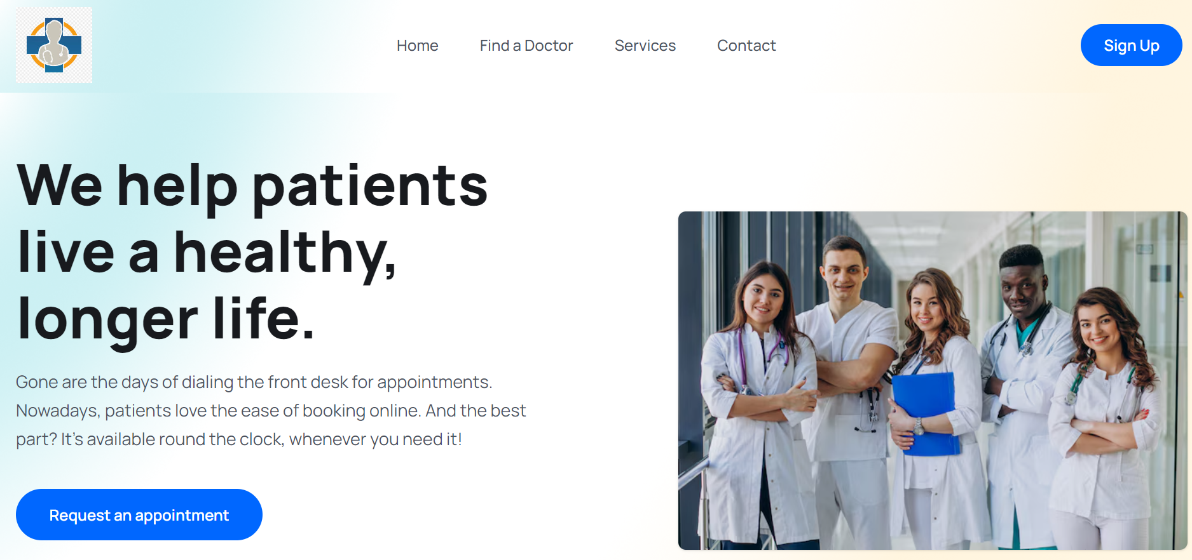

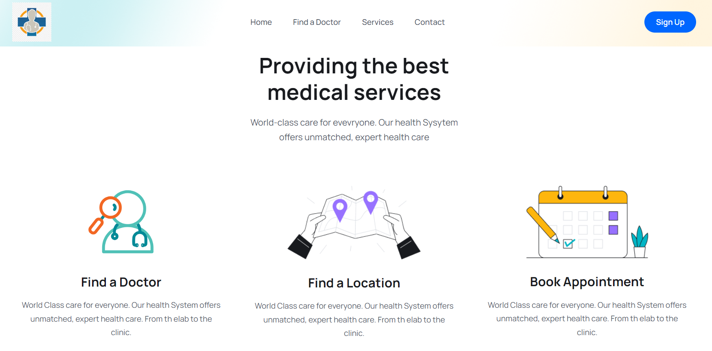

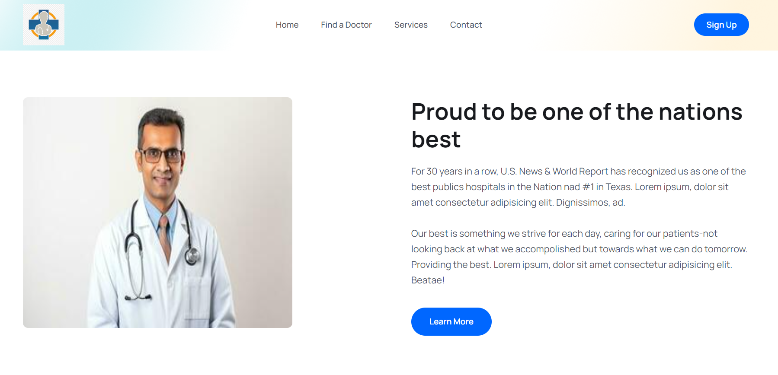

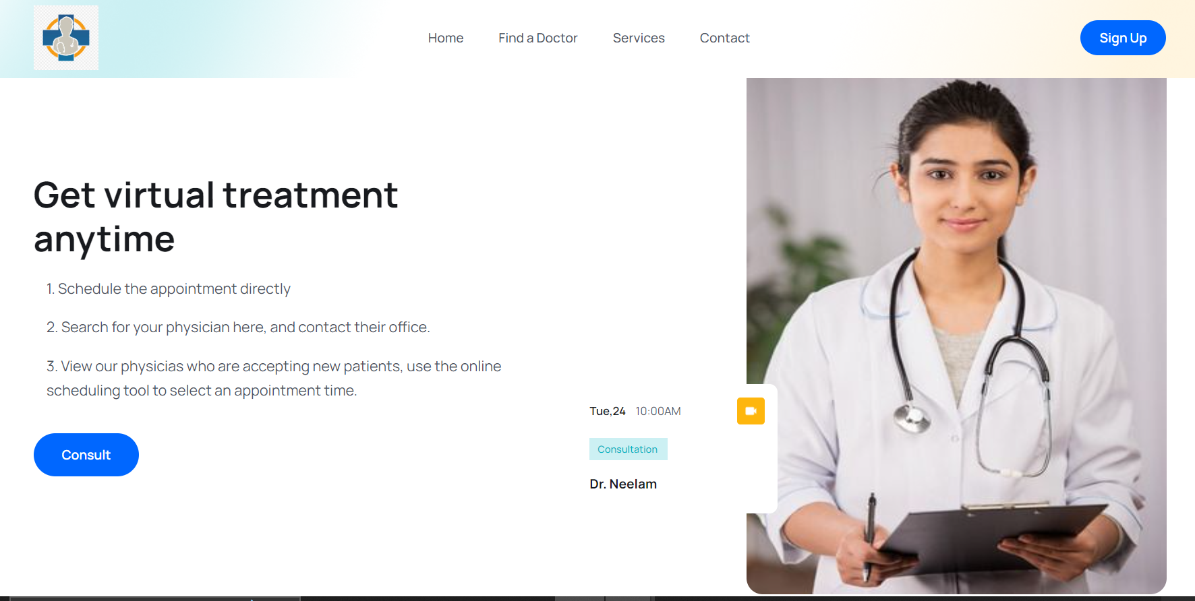

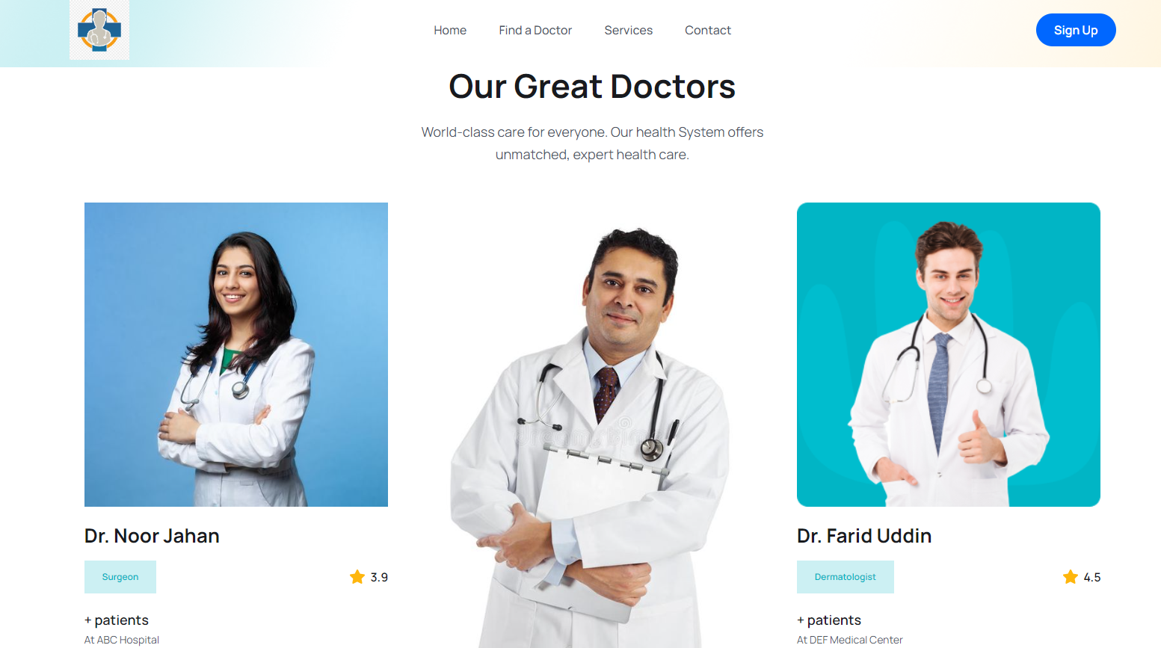

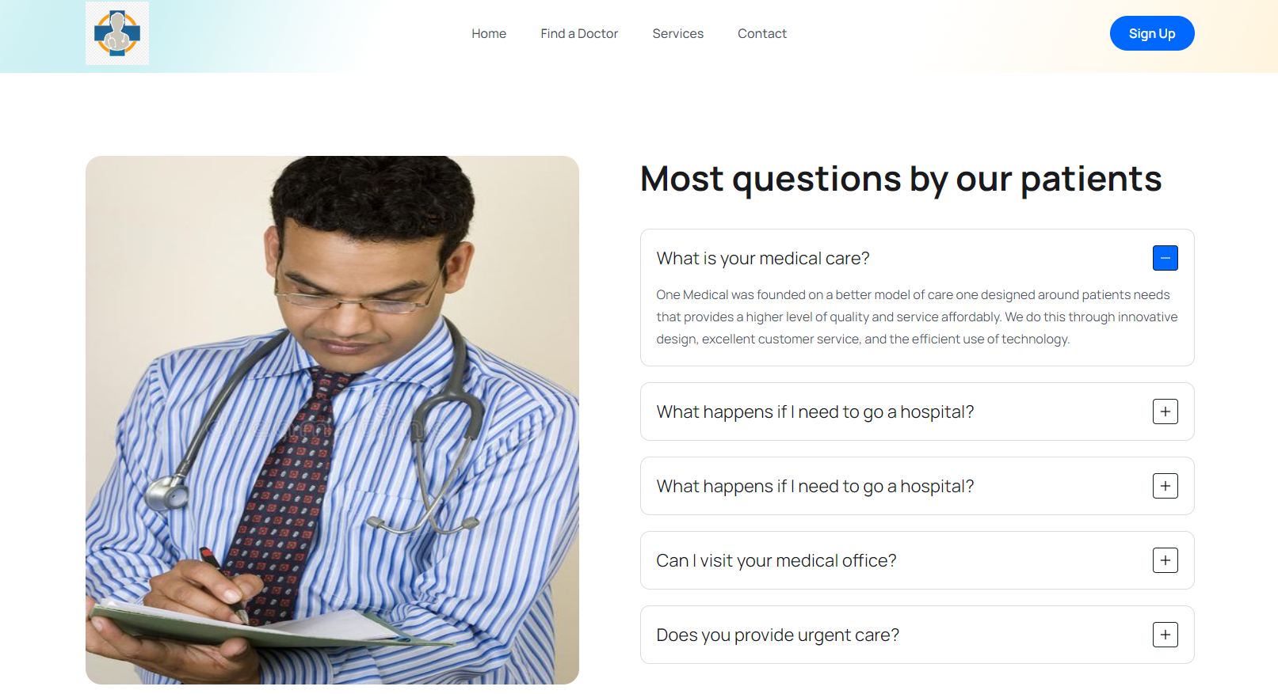

**Login page**

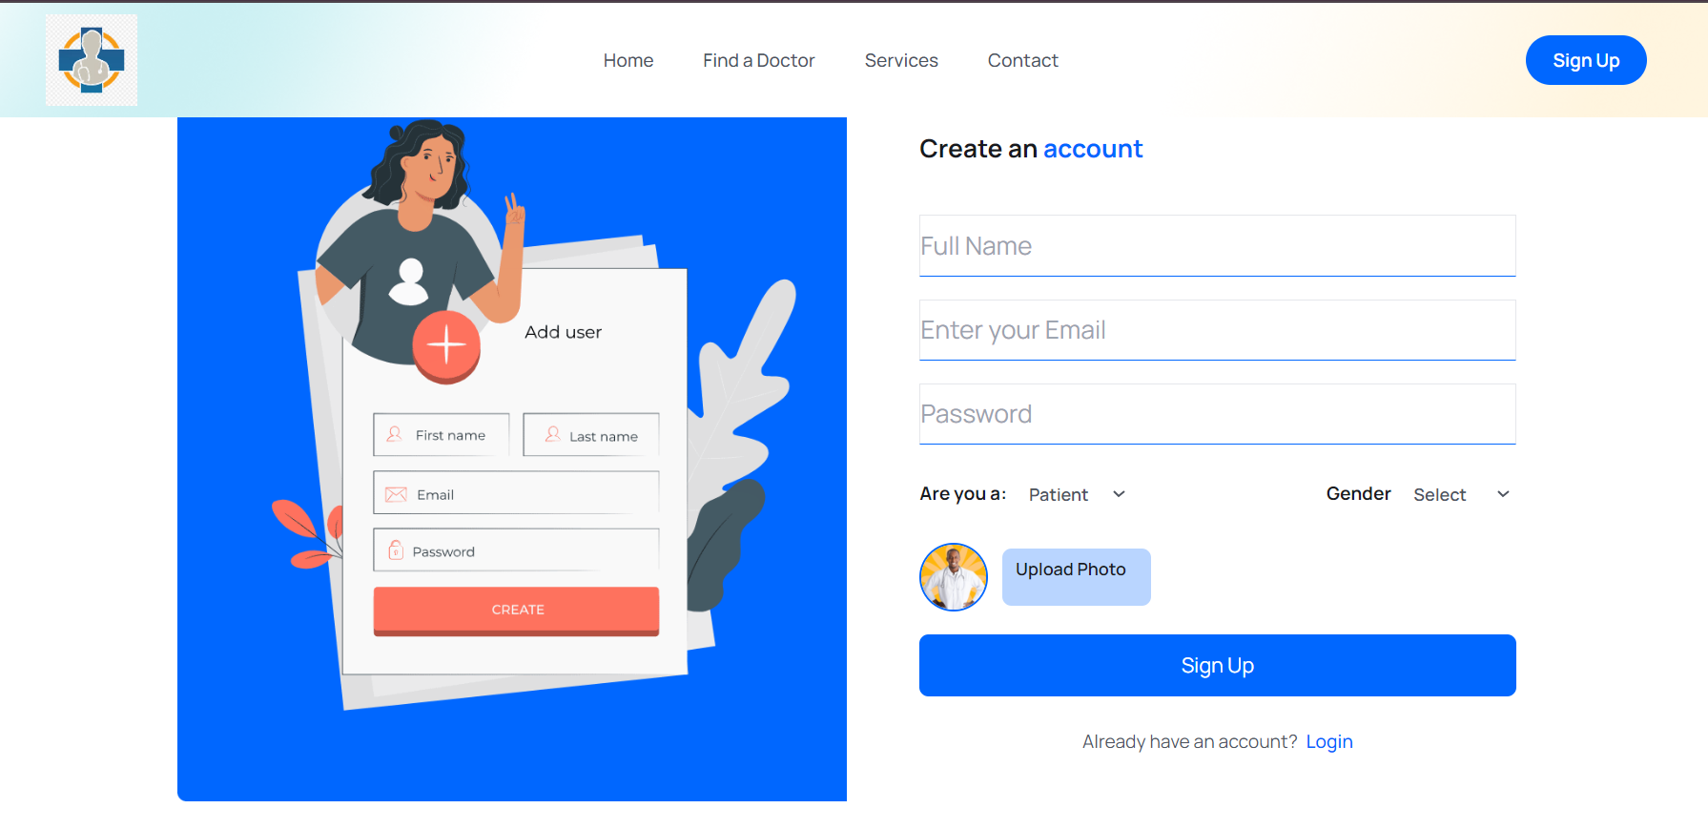

**Doctor page**

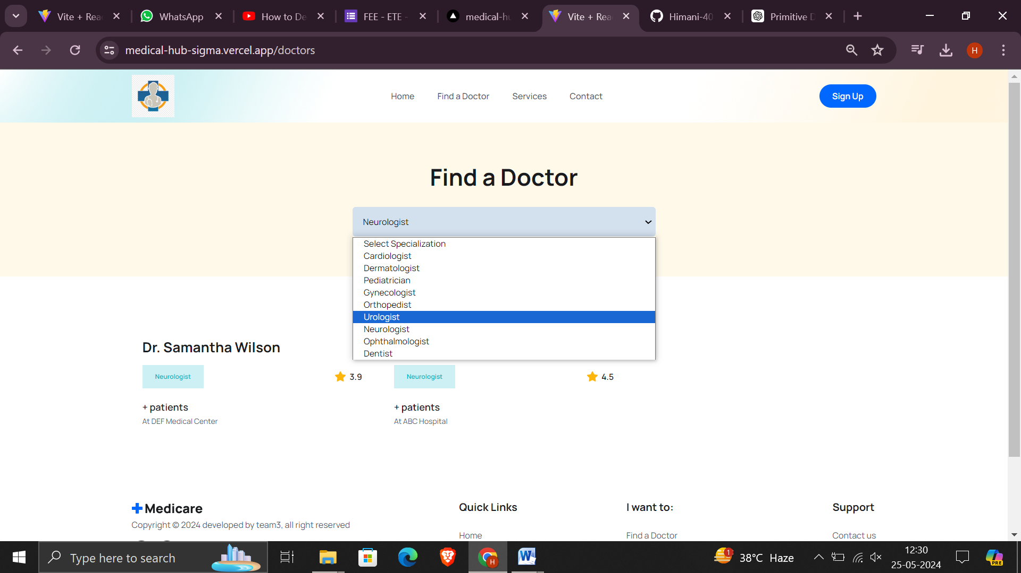

**Services page**

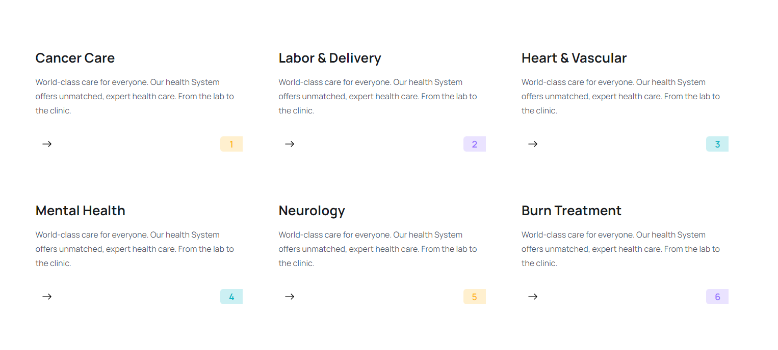

**Appointment form**

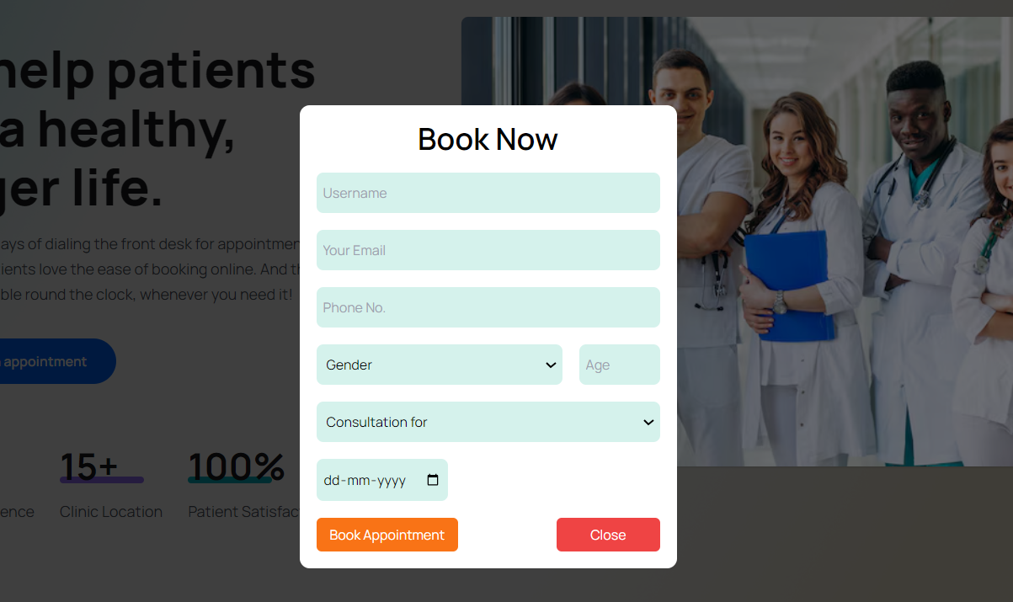

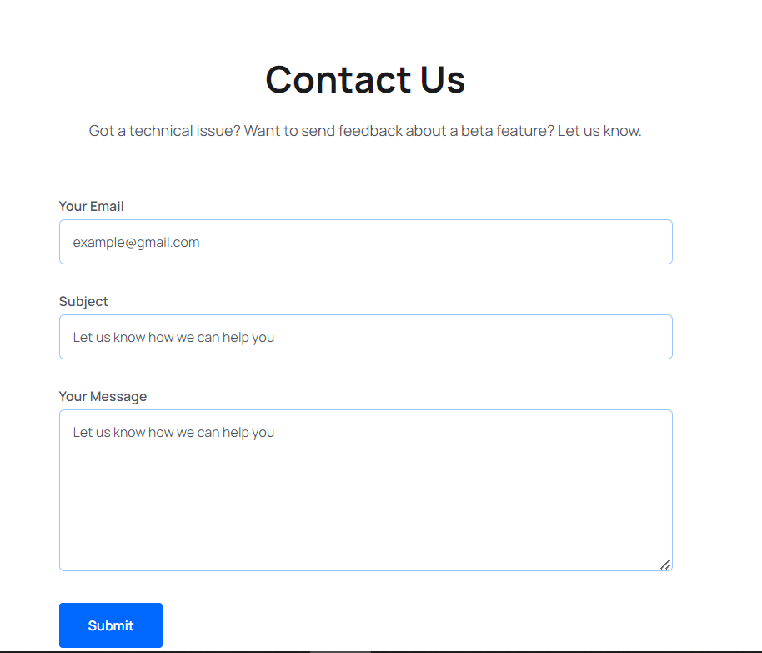

**Future scope and benefits**

The future scope of the medical appointment scheduling website includes a range of enhancements and integrations designed to further improve patient experience, accessibility, and overall efficiency. These advancements aim to keep the platform at the forefront of healthcare technology and address the evolving needs of patients and healthcare providers. Key areas for future development include:

1. **Integration of Telemedicine Services:**
   * Enable virtual consultations through secure video conferencing.
   * Allow doctors to provide remote diagnoses, consultations, and follow-ups.
   * Incorporate secure file sharing for medical records, prescriptions, and test results.
2. **AI-Driven Appointment Scheduling:**
   * Implement AI algorithms to optimize appointment slots and reduce patient wait times.
   * Use machine learning to analyze patient preferences and history for personalized doctor recommendations.
   * Provide predictive analytics to forecast appointment trends and manage doctor availability.
3. **Development of Mobile Applications:**
   * Create dedicated mobile apps for iOS and Android to increase accessibility and convenience.
   * Include push notifications for appointment reminders, updates, and health tips.
   * Offer offline access to appointment history and doctor profiles for patients in areas with limited internet connectivity.
4. **Enhanced User Experience:**
   * Develop a chatbot for 24/7 assistance with appointment booking, inquiries, and troubleshooting.
   * Introduce multilingual support to cater to a diverse patient population.
   * Improve UI/UX design based on user feedback and usability testing.
5. **Advanced Healthcare Analytics:**
   * Provide analytics dashboards for healthcare providers to monitor appointment trends, patient demographics, and satisfaction levels.
   * Offer patients insights into their health patterns and appointment history.
6. **Integration with Electronic Health Records (EHR) Systems:**
   * Facilitate seamless integration with various EHR systems to streamline patient data management.
   * Allow healthcare providers to access and update patient records in real-time during appointments.
7. **Expanding Service Coverage:**
   * Partner with more healthcare providers and hospitals to expand the network of available services.
   * Include additional types of healthcare services such as dental appointments, physiotherapy sessions, and mental health consultations.
8. **Enhanced Security Measures:**
   * Continuously update security protocols to protect against emerging threats and ensure compliance with evolving healthcare regulations.
   * Implement biometric authentication for enhanced user security.

**Conclusion**

In conclusion, our medical appointment scheduling website addresses the critical need for a more efficient, accessible, and user-friendly approach to booking medical appointments and accessing healthcare services. By integrating key features such as an intuitive appointment scheduling form, detailed doctor profiles, information on nearby hospitals, secure user accounts, and effective communication channels, the platform significantly enhances the patient experience.

Looking ahead, the future scope of this project includes exciting developments such as the integration of telemedicine services, AI-driven appointment scheduling, mobile application development, and advanced healthcare analytics. These enhancements will further streamline the process, improve patient outcomes, and ensure that the platform remains at the cutting edge of healthcare technology.

Our commitment to continuous improvement and innovation ensures that this website will not only meet the current demands of patients and healthcare providers but also adapt to future trends and challenges. By leveraging technology to simplify healthcare access, we aim to create a seamless, efficient, and satisfying experience for all users, ultimately contributing to better health outcomes and patient satisfaction.